NAME : M.BHARATHI

COLLEGE CODE : 4101

DEPARTMENT : CSE

DATA ANALYTICS WITH COGNOS

PROJECT TITLE : AIR QUALITY ANALYSIS.

PHASE 4 : Development part 2

AIM: To perform air quality analysis and create visualizations and also to calculate the SO2 and NO2 levels.

VISUALIZATION PART:

import warnings

warnings.filterwarnings('ignore')

import pandas as pd

import matplotlib.pyplot as plt

import seaborn as sns

import numpy as np

df=pd.read_csv('weather.csv')

df.hist(bins=50, figsize=(15,15))

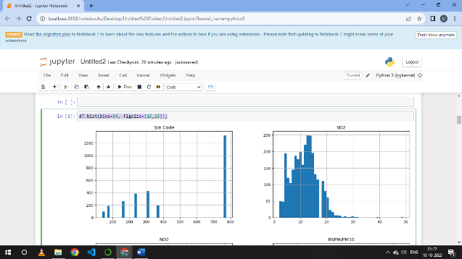

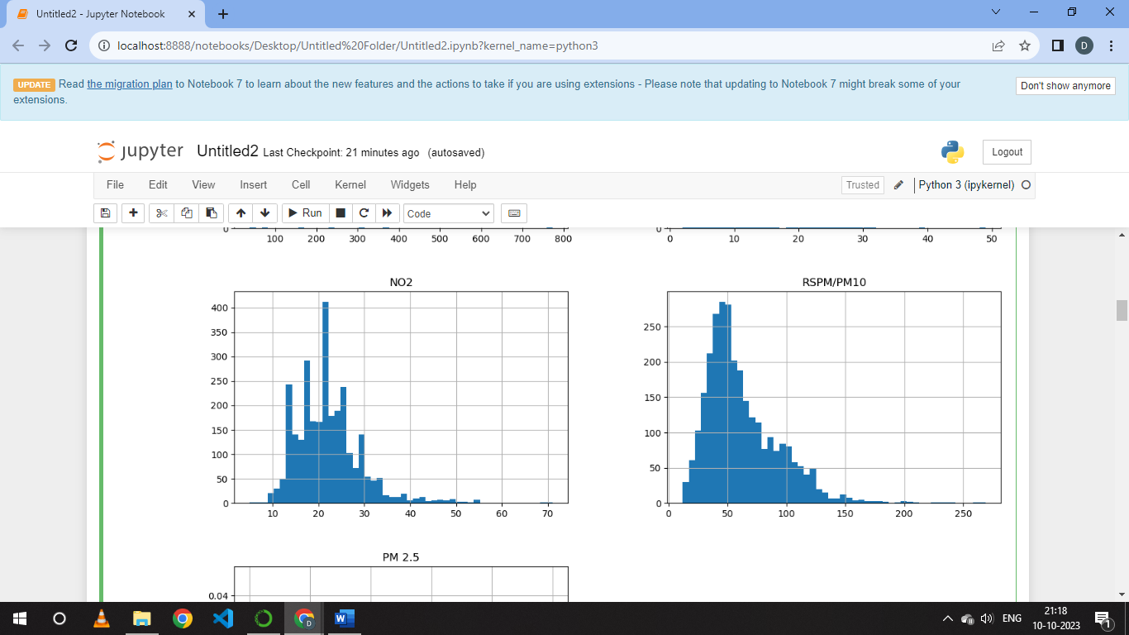

import plotly.express as px

fig1 = px.scatter(df,x='City/Town/Village/Area',y='SO2')

fig1.show()

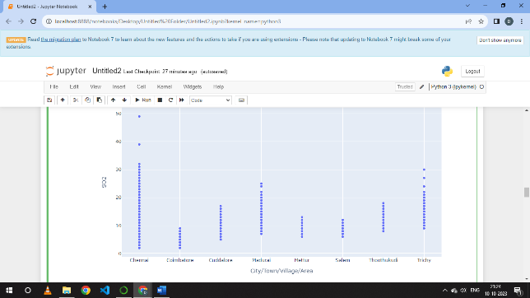

fig2 = px.scatter(df,x='City/Town/Village/Area',y='NO2')

fig2.show()

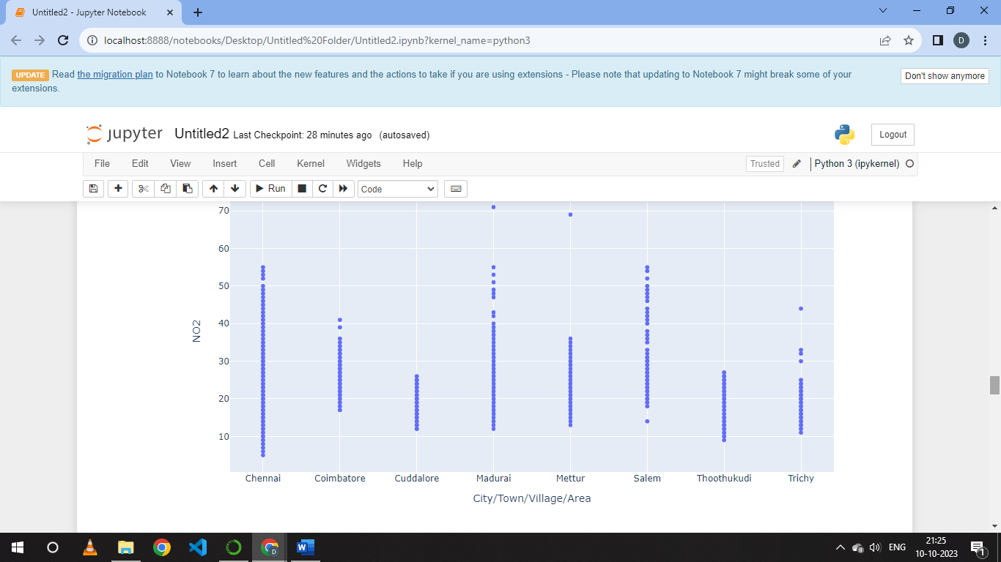

df[['SO2','City/Town/Village/Area']].groupby(["City/Town/Village/Area"]).mean().sort_values(by='SO2').head(20).plot.bar(color='b')

plt.show()

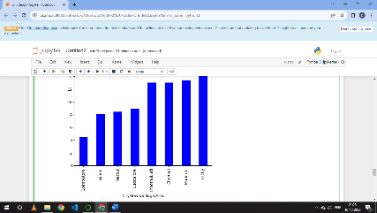

CALCULATION PART :

1.Calculating SO2 :

def cal_SOi(SO2):

si=0

if (SO2<=40):

si= SO2*(50/40)

elif (SO2>40 and SO2<=80):

si= 50+(SO2-40)*(50/40)

elif (SO2>80 and SO2<=380):

si= 100+(SO2-80)*(100/300)

elif (SO2>380 and SO2<=800):

si= 200+(SO2-380)*(100/420)

elif (SO2>800 and SO2<=1600):

si= 300+(SO2-800)*(100/800)

elif (SO2>1600):

si= 400+(SO2-1600)*(100/800)

return si

df['SOi']=df['SO2'].apply(cal_SOi)

dff= df[['SO2','SOi']]

dff.head()

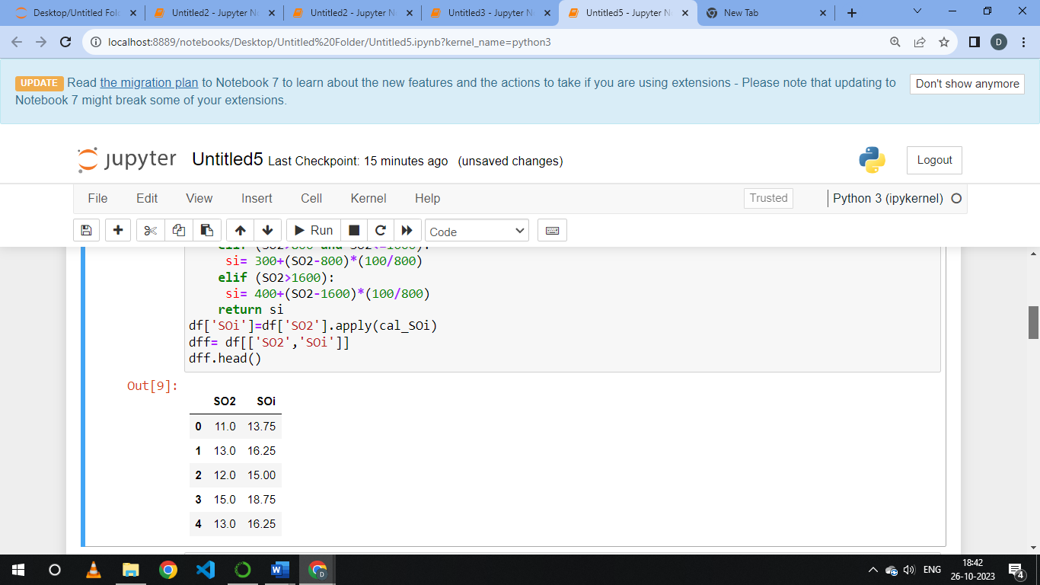

2. Calculating NO2 :

def cal_NOi(NO2):

ni=0

if (NO2<=40):

ni= NO2*(50/40)

elif (NO2>40 and NO2<=80):

ni= 50+(NO2-40)*(50/40)

elif (NO2>80 and NO2<=380):

ni= 100+(NO2-80)*(100/300)

elif (NO2>380 and NO2<=800):

ni= 200+(NO2-380)*(100/420)

elif (NO2>800 and NO2<=1600):

ni= 300+(NO2-800)*(100/800)

elif (NO2>1600):

ni= 400+(NO2-1600)*(100/800)

return ni

df['NOi']=df['NO2'].apply(cal_NOi)

dff= df[['NO2','NOi']]

dff.head()

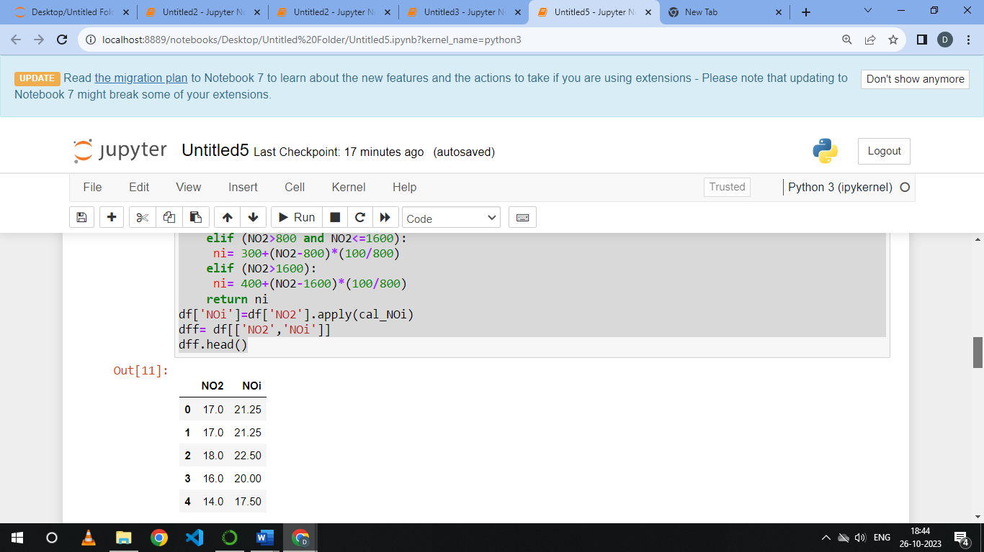

TREND MOST AFFECTED CITY :

city = df.groupby('City/Town/Village/Area')[‘RSPM/PM10’].sum().reset_index()

most_affected_city = city.loc[city[‘RSPM/PM10'].idxmax()]

print("The most affected city is:", most_affected_city['City/Town/Village/Area']) 